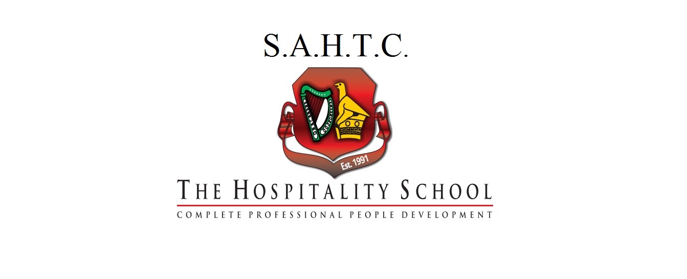

Thank you for visiting S.A.H.T.C.-The Hospitality School. We offer diploma programs in International Hospitality Management as well as Food Preparation and Culinary Arts.

**Minimum requirements**

5 IGCSE Cambridge or ZIMSEC O'level Passes including English. (Or equivalent)

**Intakes**

We have three intakes per year: February, May and September.

**FEES**

* Fees depend on program selected but range from about $5,800 USD to $8,400 USD per year.
* Most of our programs are 1- 2 years long.

* **Fees include**:
  1. Tuition
  2. Textbooks
  3. Exam costs
  4. Fees also include the provision of a Chefs Uniform (for Culinary Arts Students Only).

**Payment Plans**

We generally offer 3 types of payment plans that allow you to pay in instalments:

Option 1: once-off payment for the year

Option 2: two-four instalments per year

Option 3: 10-12 instalments per year

**Courses on Offer**

1. International Hospitality Management – 2 years (Excluding Intership Year) -$6,900 - $8,400 per year
2. Chefs on Stage: Food Preparation and Culinary Arts Program – 2 years (Excluding Internship Year) – $5,800 - $7,000USD per year

**Foreign Language and Digital Skills Passport**

All of our trainees are encouraged to obtain an additional internationally spoken language as well as knowledge on the use of computers. These two programs are compulsory unless student has already completed and has been certified.

**To apply:**

Kindly visit our website: [www.sahtc.com](http://www.sahtc.com) to download application forms.

Submit the application in hardcopy form at our offices. We are located at 60 Colquhoun Street, Corner Fife Avenue, Harare, Zimbabwe. Application forms can also be emailed to [info@sahtc.com](mailto:info@sahtc.com).

Applicant must attach the following to the application form:

1. CV/Resume

2. A full length photograph.

3. O'level results or any other official secondary/post high school results they may have

4. Copy of their I.D. (or passport if foreign National).

5. Application fee is $75.00 USD. Modes of payment are: Cash, Ecocash, bank deposit, bank transfer.

* International applicants and non-Harare based applicants may submit their application form (and above documentation) via email: info@sahtc.com

**Please visit our website** [www.sahtc.com](http://www.sahtc.com) **for more information and a complete list of the programs we offer!**

**Contact: 0774 645 555 (WhatsApp)**